**01. EKS Cluster Autoscaler - Introduction**

--- We are looking into cluster auto scalar from EKS.

--- how we are going to do the cluster node groups autoscaling, inside the group. How we are going to have to scale the EC2 worker node.

**Introduction**

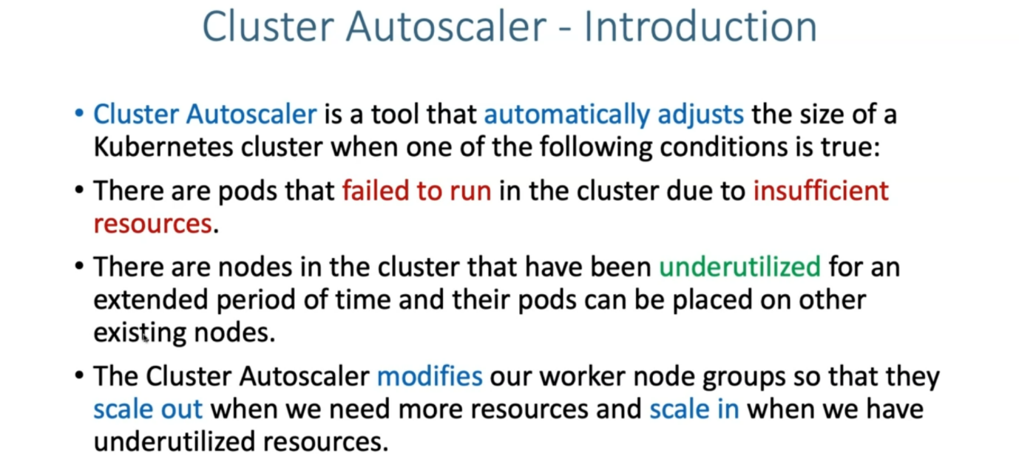

--- So, on a very high level, cluster auto scalar is a tool that automatically adjust the size of a kubernetes cluster, when one of the following conditions is true.

--- there are pods that fail to run in the cluster due to insufficient resources during that time. Cluster auto scalar will increase the number of nodes so that these pods get sufficient resources to schedule on the new nodes.

--- there are nodes in the cluster that have been under-utilized for an extended period of time and

their pods can be placed on other existing nodes and then these under-utilized nodes can be removed from the cluster and then get terminated.

--- from cost point of view, cluster auto scalar helps a lot for us in increasing or decreasing.

--- from performance point of view, for increasing the number of nodes or scaling up the number of nodes helps us.

--- from cost perspective, it saves us when we are not using the resources.

--- It can scale down and then help us from cost perspective.